**Lab 3: Assigning Static IP Address in windows**.

**Objective(s):**

* To assign static IP address and practice the commands used to assign static IP address

**Apparatus:** Command Prompt

**Background:**

A static IP address is an unchanging number assigned to a computer by an Internet service provider (ISP) and is used to identify with a specific address instead of one that is assigned temporarily. Dynamic Host Configuration Protocol (DHCP) is a handy way for devices to connect to user network more easily, because user don’t have to configure IP addressing for each new device themselves. The downside to automatic addressing is that it’s possible for a device’s IP address to change from time to time, which is why people choose static IPs for certain types of devices.

**Procedure:** To do these practical following steps should be done:

Step 1: Press the windows key and type cmd in search bar.

Step 2: Select Command Prompt and click run as administrator.

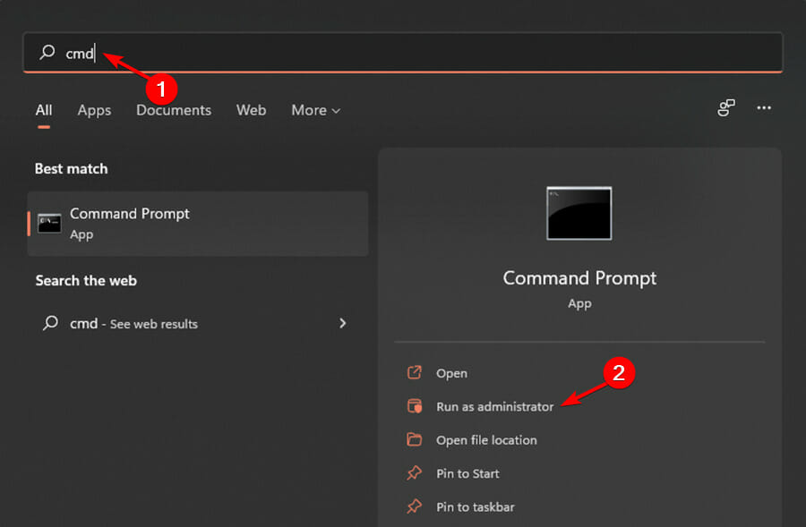

Step 3: Run command “ipconfig /all”

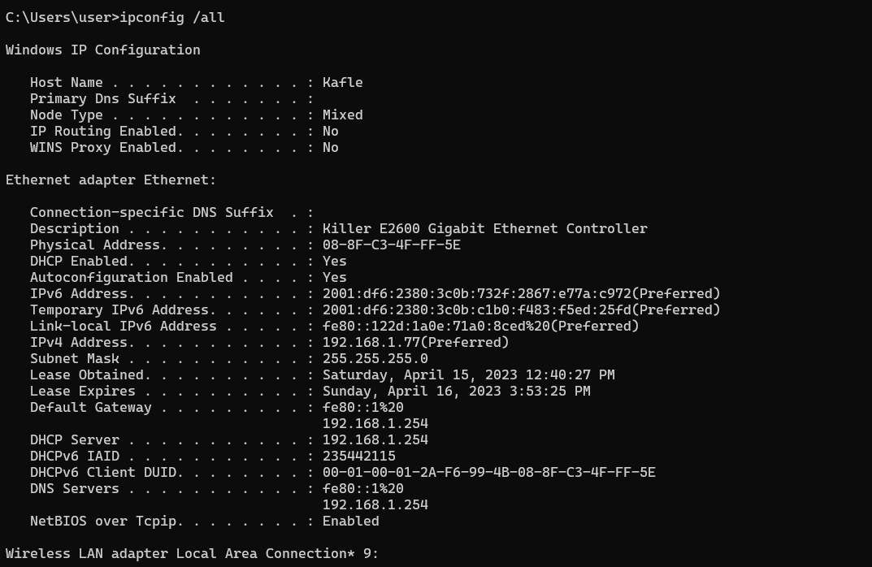

Step 4: Run command “netsh interface ip set address name="Ethernet"

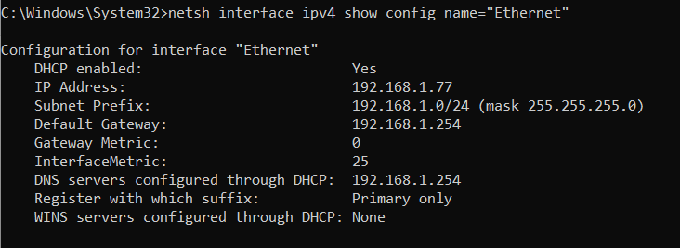

Step 5: Run command “netsh interface ip set address name="Ethernet0" static 10.1.2.220 255.255.255.0 10.1.2.1” 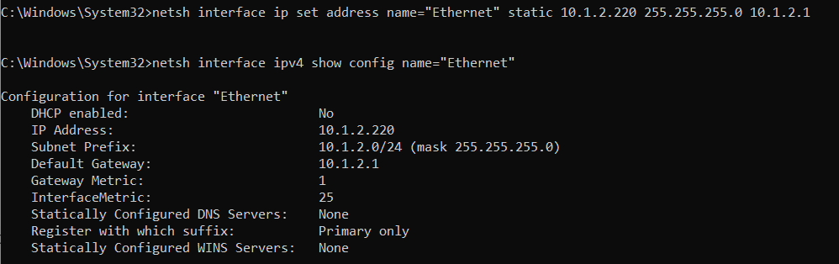

Step 6: Finally, run command “netsh interface ip add dns name="Ethernet0" 8.8.8.8 index=2” to assign an alternate DNS address.



**Conclusion:** After assigning Static IPit’s not possible for a device’s IP address to change from time to time until it is manually changed by the user.